FRASER COAST SOCIAL RIDERS WEB STATS MAY 2011
Summary May 2011
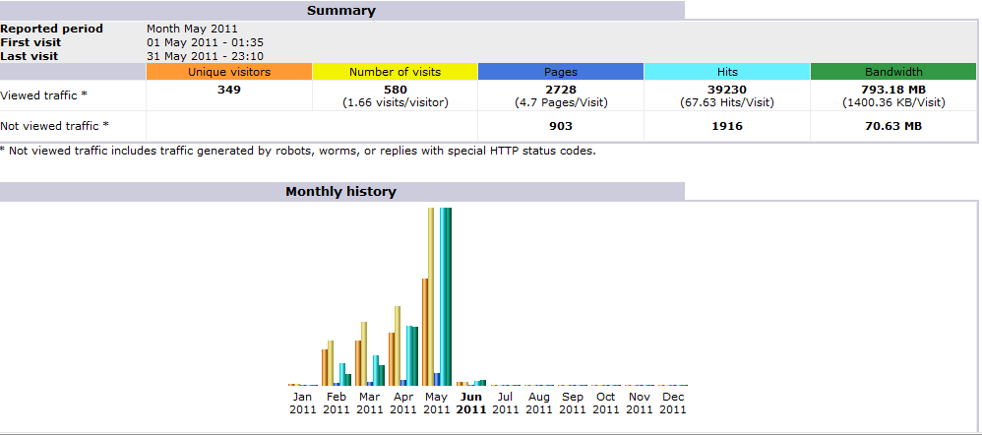
Bumber of Visitors, Hits by month

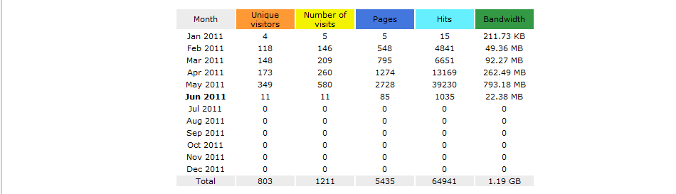
Usage by time of day
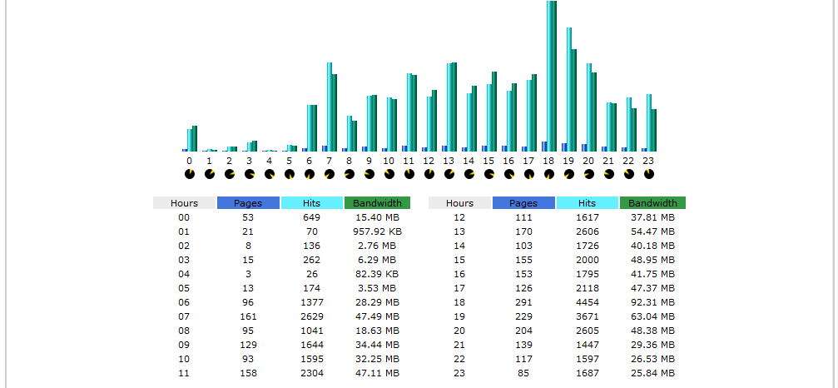

What countries access our site May 2011
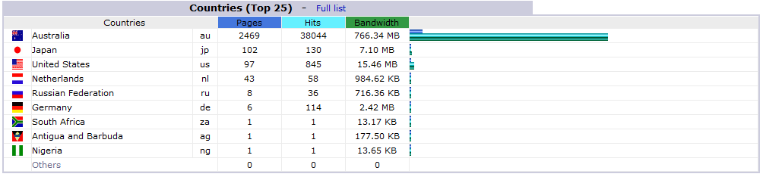
How long people stay on our site May 2011
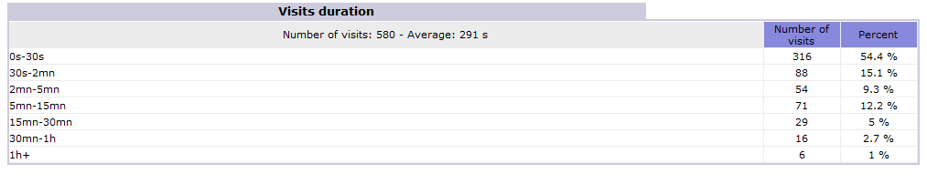
Most popukar links on our website for May 2011
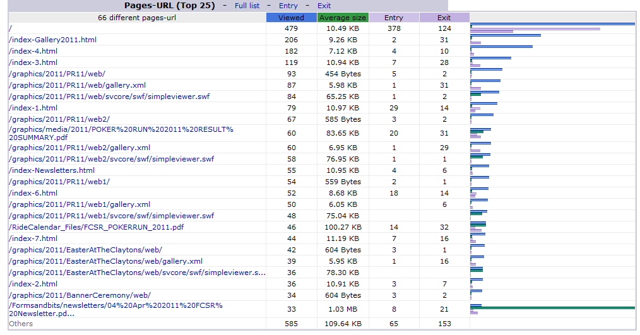
What Browsers are used to access our web site May 2011
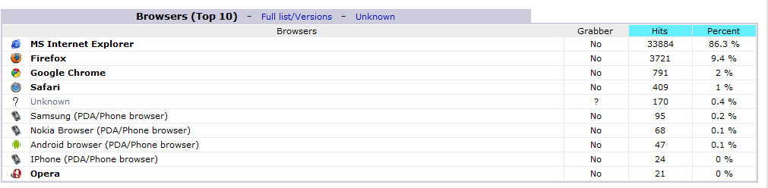

Where/how people connect to our website May 2011
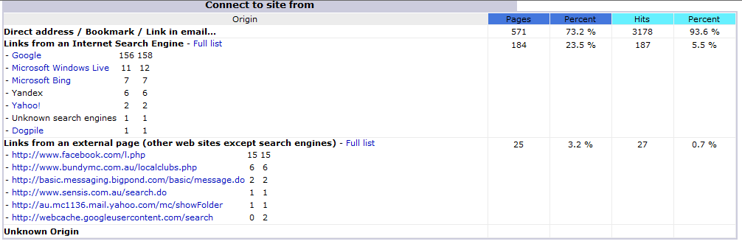
How people find or search for our site May 2011
